Enterprise-Level Code Architecture For Back-End using Laravel

1. Controller (HTTP Layer Only)
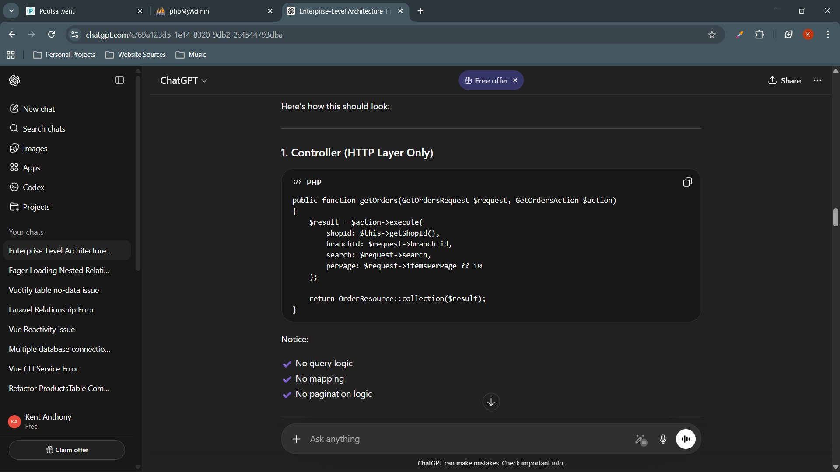

✔ No query logic
✔ No mapping
✔ No pagination logic

2. Action (Business Use Case)

Create file: app/Actions/Orders/GetOrdersAction.php
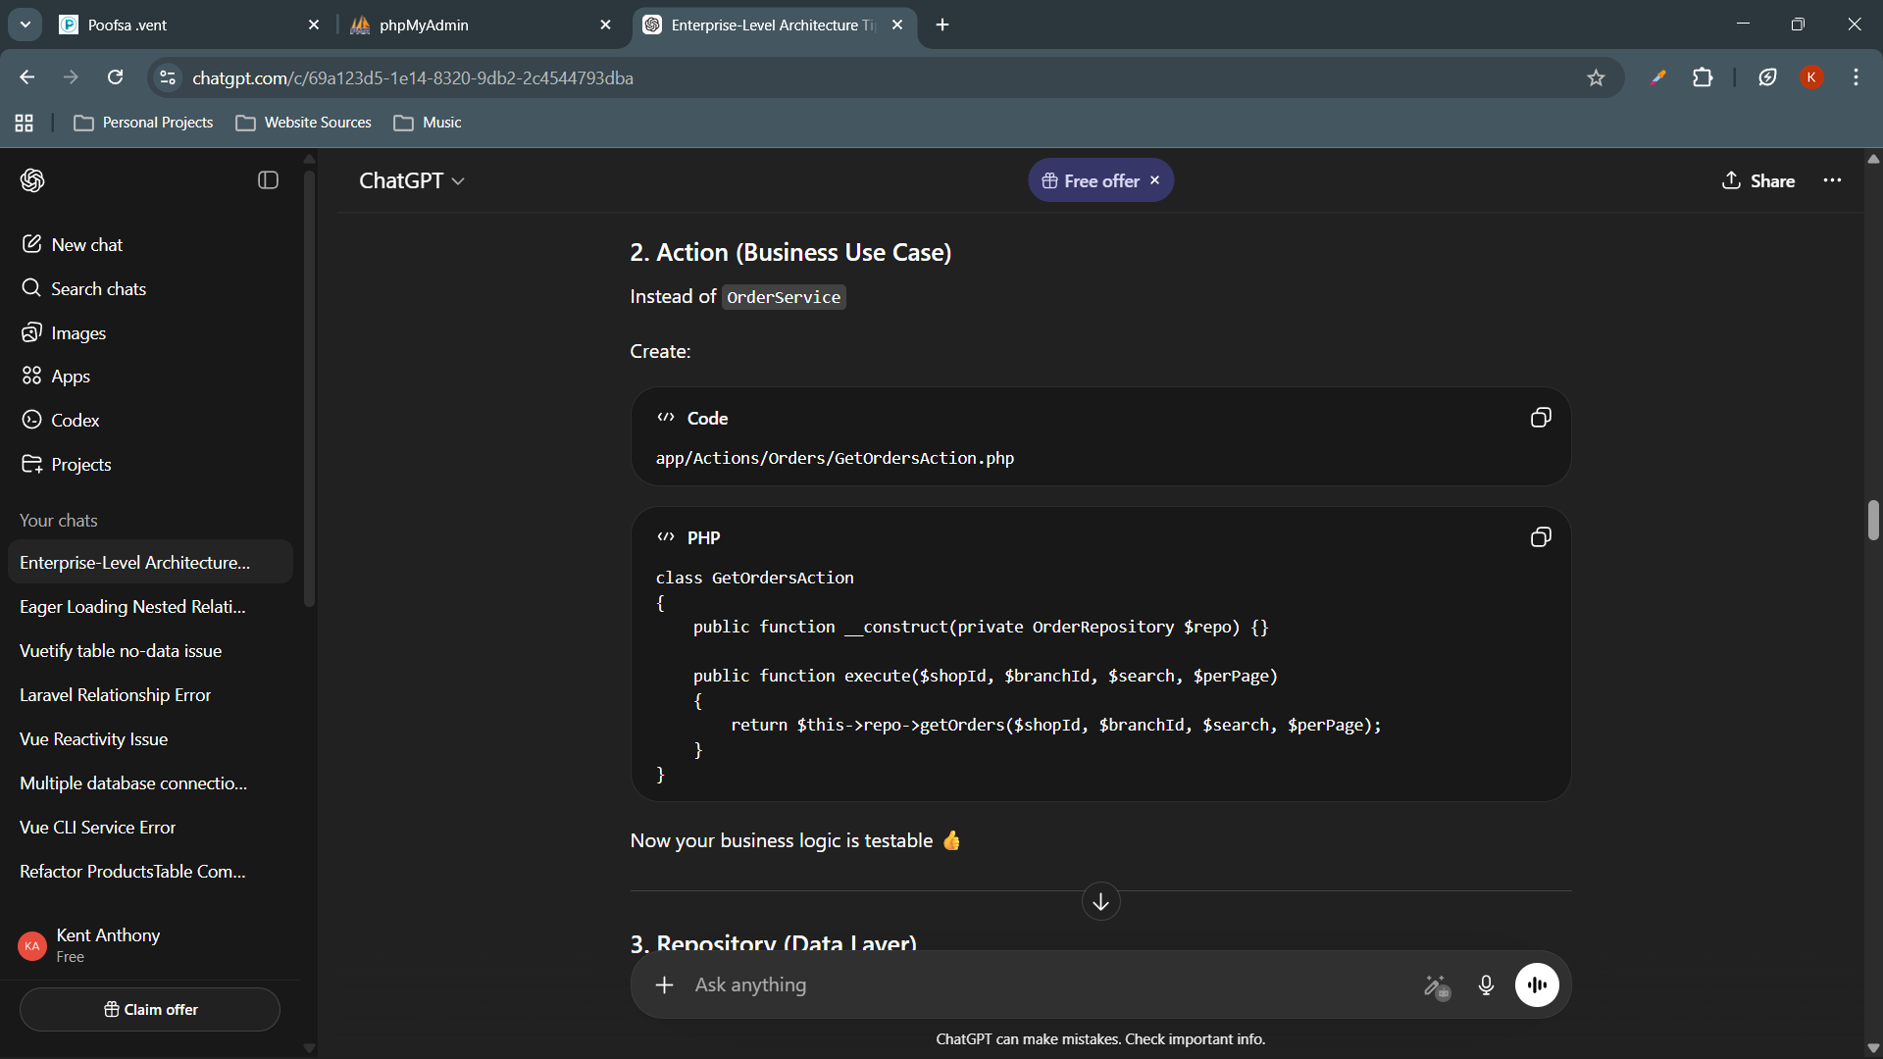

Now, the business logic is testable

Note: Unlike Static classes are hard to:
Mock, Test, and Inject dependencies

3. Repository (Data Layer)

Create file: app/Repositories/OrderRepository.php

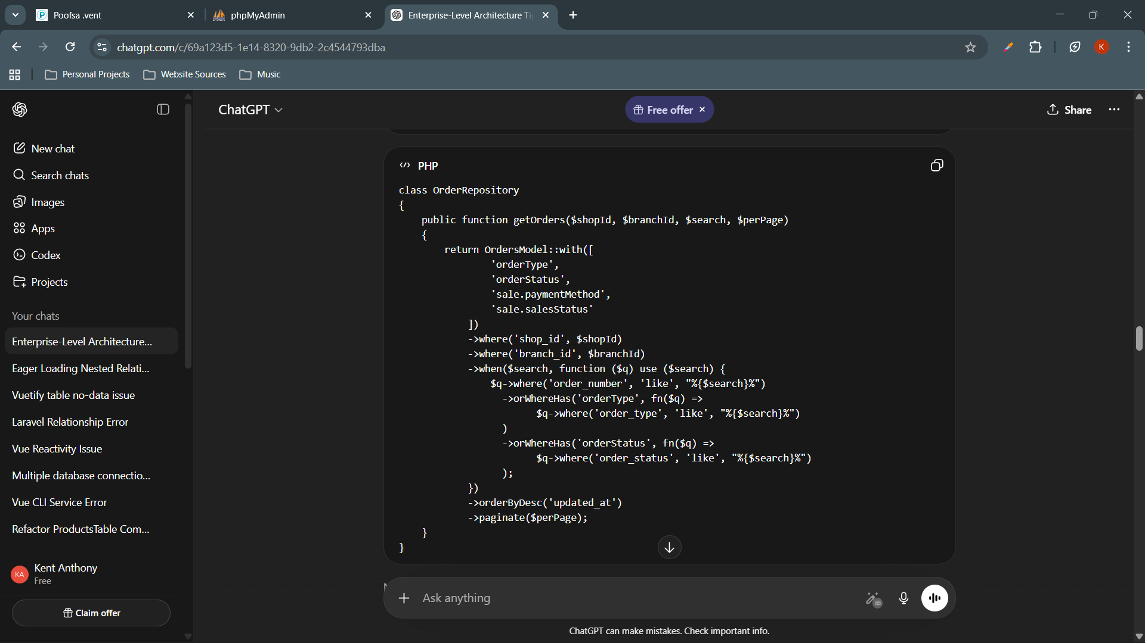

✔ Replaceable
✔ Cacheable
✔ Testable

4. Resource (Presentation Layer)

Create file: app/Http/Resources/OrderResource.php
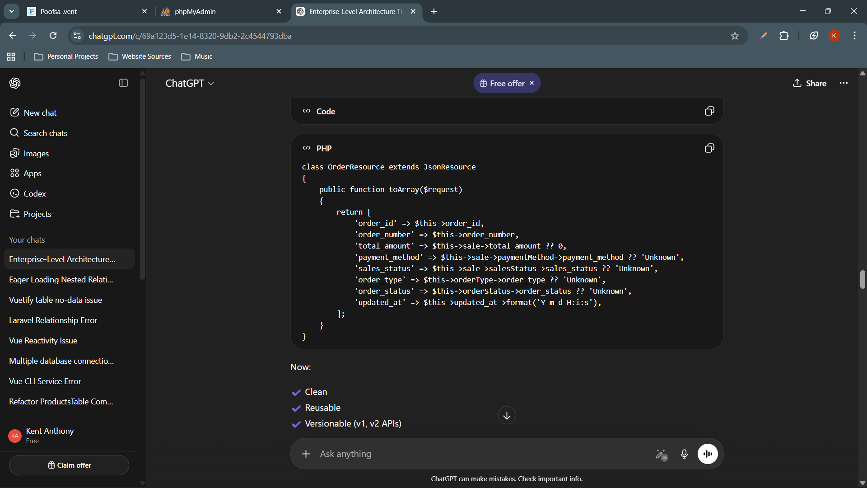

✔ Clean
✔ Reusable
✔ Versionable (v1, v2 APIs)
Enterprise-level Flow

Route
↓
Controller
↓
Action (Use Case)
↓
Repository
↓
Model
↓
Resource
↓
Response

= = = = = = = = =

In enterprise design, these are separate responsibilities
- Query builder
- Business logic
- Data transformer (mapping)
- Pagination handler

= = = = = = = =
Add Repository Layer because without repository → everything breaks.
Someday you might:
- Change database
- Add caching (Redis)
- Call external API instead of DB
- Add read replicas

